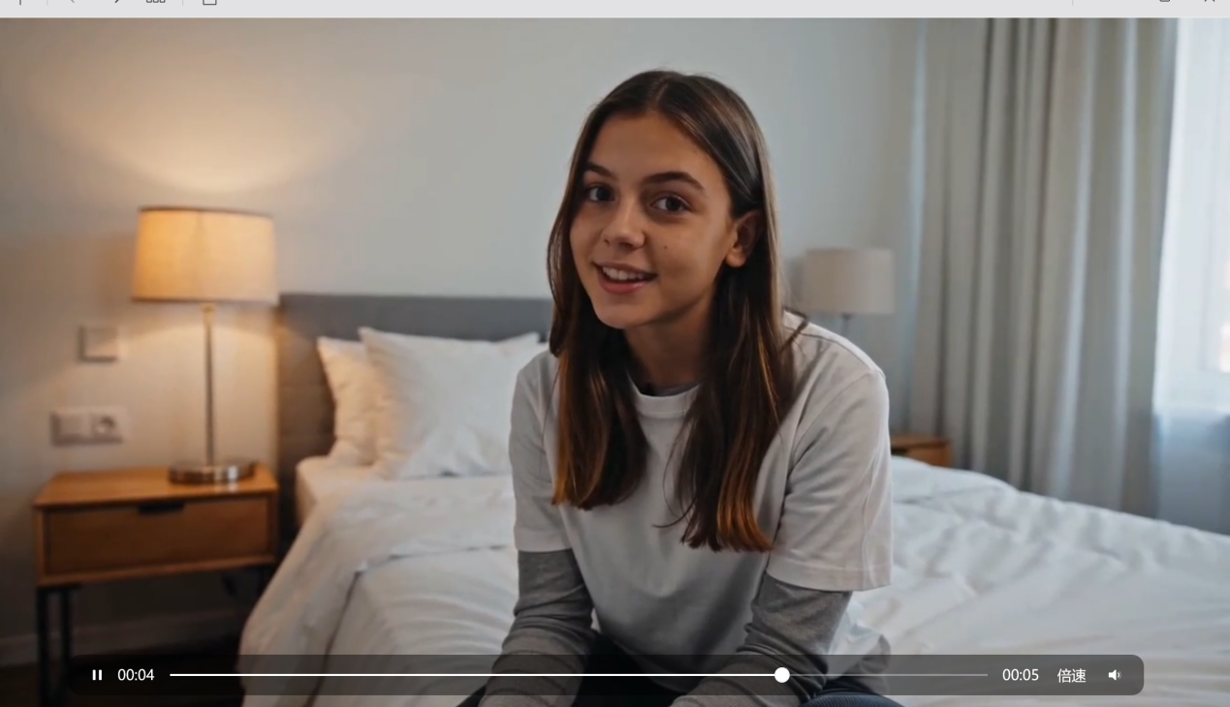
SCENE 1 — PRESENT DAY INTRO

“modern bedroom vlog setup in 2020s, soft natural lighting, casual aesthetic, a young woman sitting in her room talking directly to camera, realistic smartphone vlog style, cozy but modern environment, subtle handheld camera movement, cinematic but relatable atmosphere”
场景 1 — 现代开场介绍
“2020年代的现代卧室 vlog 场景，柔和的自然光，休闲随性的美学风格，一位年轻女性坐在自己的房间里直接对着镜头讲话，真实的智能手机 vlog 风格，温馨但现代的环境，轻微的手持镜头晃动，电影感但又贴近日常的氛围。”
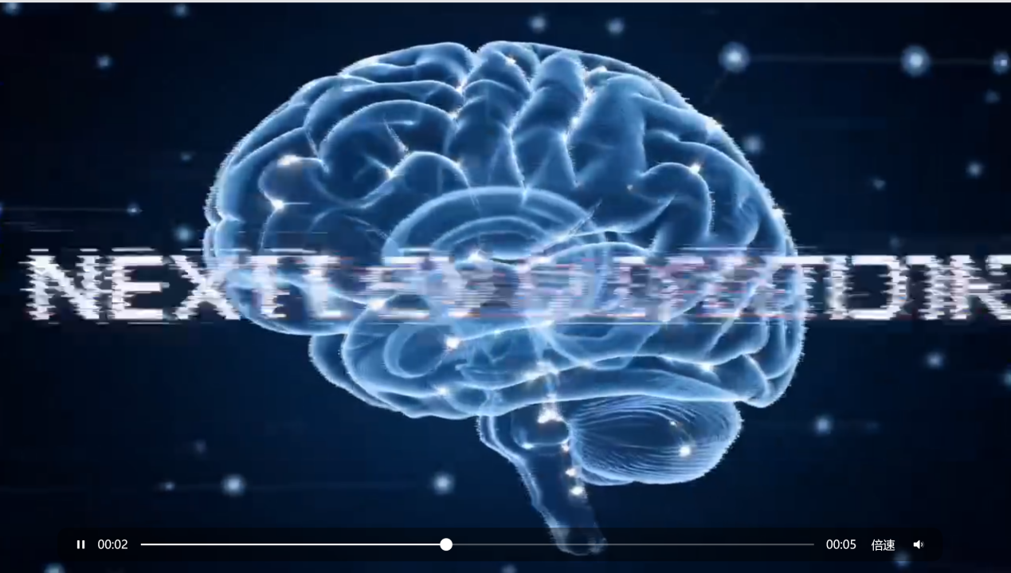
SCENE 2 — FUTURE PREDICTIONS MONTAGE

“fast-paced futuristic concept montage, people imagining future technology, transparent smartphones, brain microchips, exaggerated futuristic ideas, sleek modern editing style, social media aesthetic, cinematic transitions”
场景 2 — 未来预测蒙太奇
“快节奏的未来概念蒙太奇，人们想象未来科技，透明智能手机，大脑微芯片，夸张的未来主义想法，流畅高级的现代剪辑风格，社交媒体美学，电影感转场。”
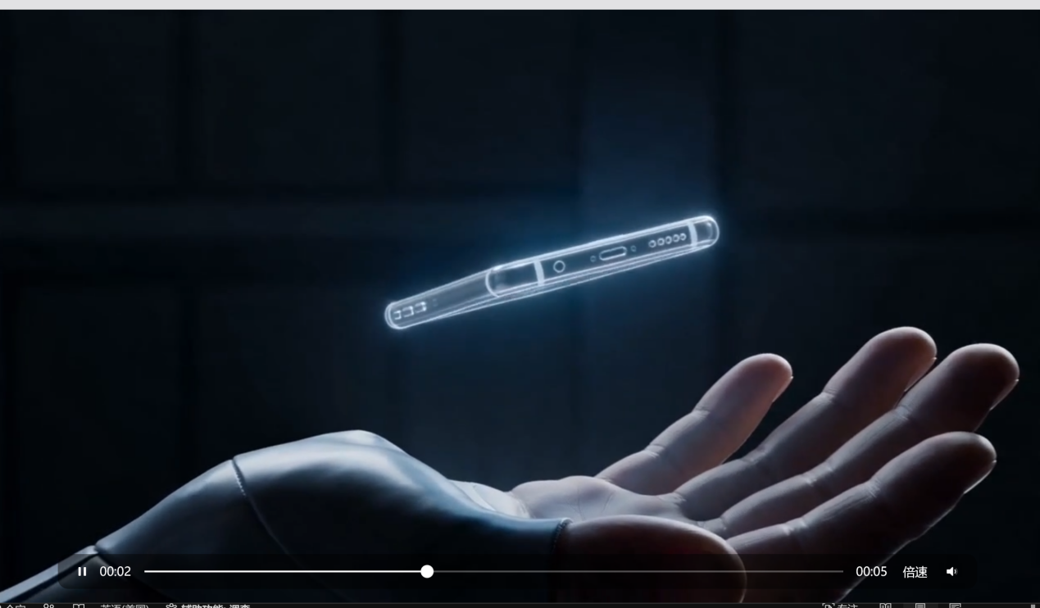
SCENE 3 — TRANSPARENT PHONE CONCEPT

“futuristic transparent smartphone floating in someone’s hand, clean minimal sci-fi aesthetic, cinematic lighting, elegant futuristic technology concept, ultra realistic”
场景 3 — 透明手机概念
“未来感透明智能手机悬浮在某人手中，干净极简的科幻美学风格，电影感灯光，优雅的未来科技概念，超写实。”
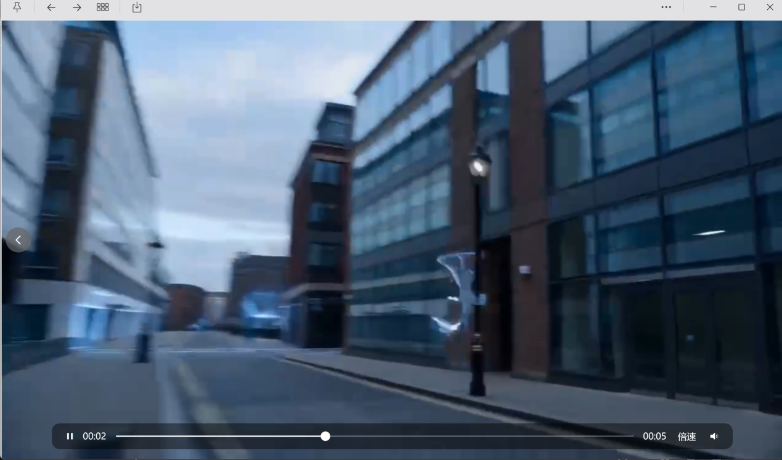
SCENE 4 — TRANSITION TO 2070

“smooth cinematic transition from present day into the year 2070, digital glitch effects, futuristic architecture appearing, holographic advertisements floating through the city, immersive sci-fi realism, emotional and futuristic atmosphere”
场景 4 — 过渡到 2070 年
“从现代平滑而富有电影感地过渡到 2070 年，带有数字故障特效，未来主义建筑逐渐出现，全息广告漂浮在城市之中，沉浸式科幻写实风格，兼具情感张力与未来感的氛围。”
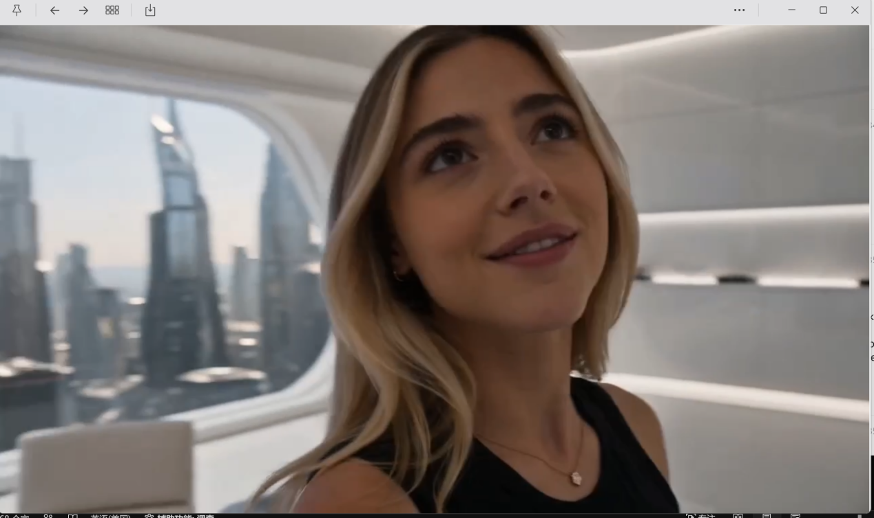
SCENE 5 — FUTURE CITY + PHONE REVEAL

“cinematic futuristic 2070 environment, immersive premium future city with soft ambient lighting, holographic advertisements and sleek architecture in the background, a young woman walking naturally through the environment, then slowly taking a futuristic premium flip smartphone out of her pocket, subtle emphasis on the elegant device reveal while maintaining focus on the futuristic surroundings and atmosphere, cinematic camera movement, realistic sci-fi aesthetic, ultra detailed”
场景 5 — 未来城市 + 手机亮相
“电影感十足的 2070 年未来环境，沉浸式高端未来城市，带有柔和的环境光，背景中有全息广告和流线型建筑，一位年轻女性自然地走在这个环境中，然后慢慢从口袋里拿出一部高端未来感翻盖智能手机，在保持画面重点仍然放在未来环境与整体氛围的同时， subtly 突出这款优雅设备的亮相，电影感镜头运动，写实科幻美学风格，超高细节。”
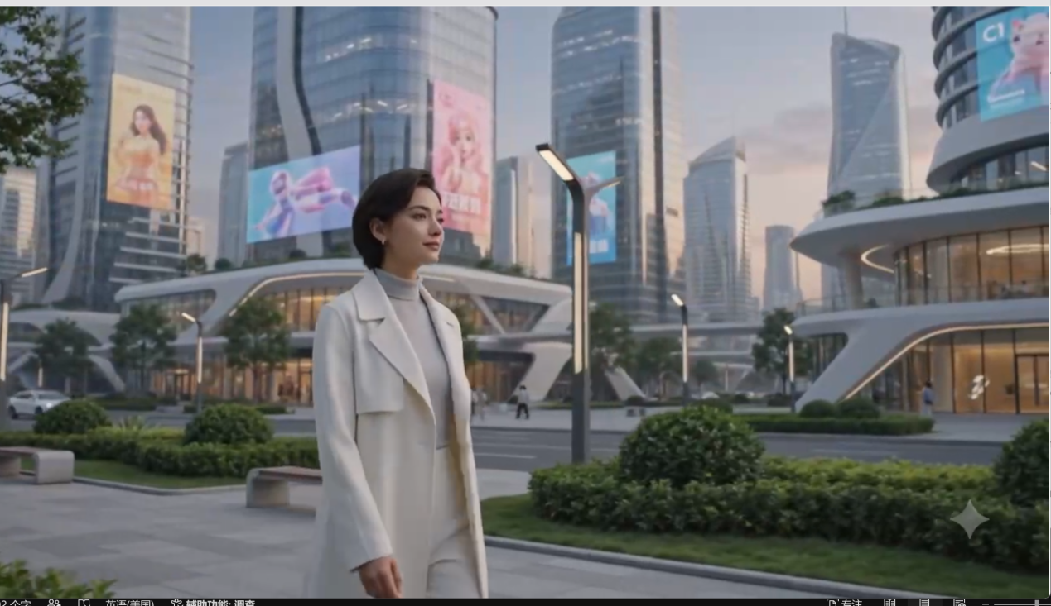
Generate 16:9 video cinematic futuristic 2070 environment, immersive premium future city with soft ambient lighting, holographic advertisements and sleek architecture in the background, a young woman walking naturally through the environment, then slowly taking a futuristic premium flip smartphone out of her pocket, subtle emphasis on the elegant device reveal while maintaining focus on the futuristic surroundings and atmosphere, cinematic camera movement, realistic sci-fi aesthetic, ultra detailed”
“生成一段 16:9 的视频：电影感十足的 2070 未来环境，沉浸式、高端的未来城市，带有柔和的环境光，背景中有全息广告和流线型建筑；一位年轻女性自然地行走在环境中，然后慢慢地从口袋里拿出一部高端未来感翻盖智能手机；在保持画面重点仍放在未来环境与整体氛围的同时，微妙地突出这款优雅设备的亮相；电影感镜头运动，写实科幻美学，超高细节。”
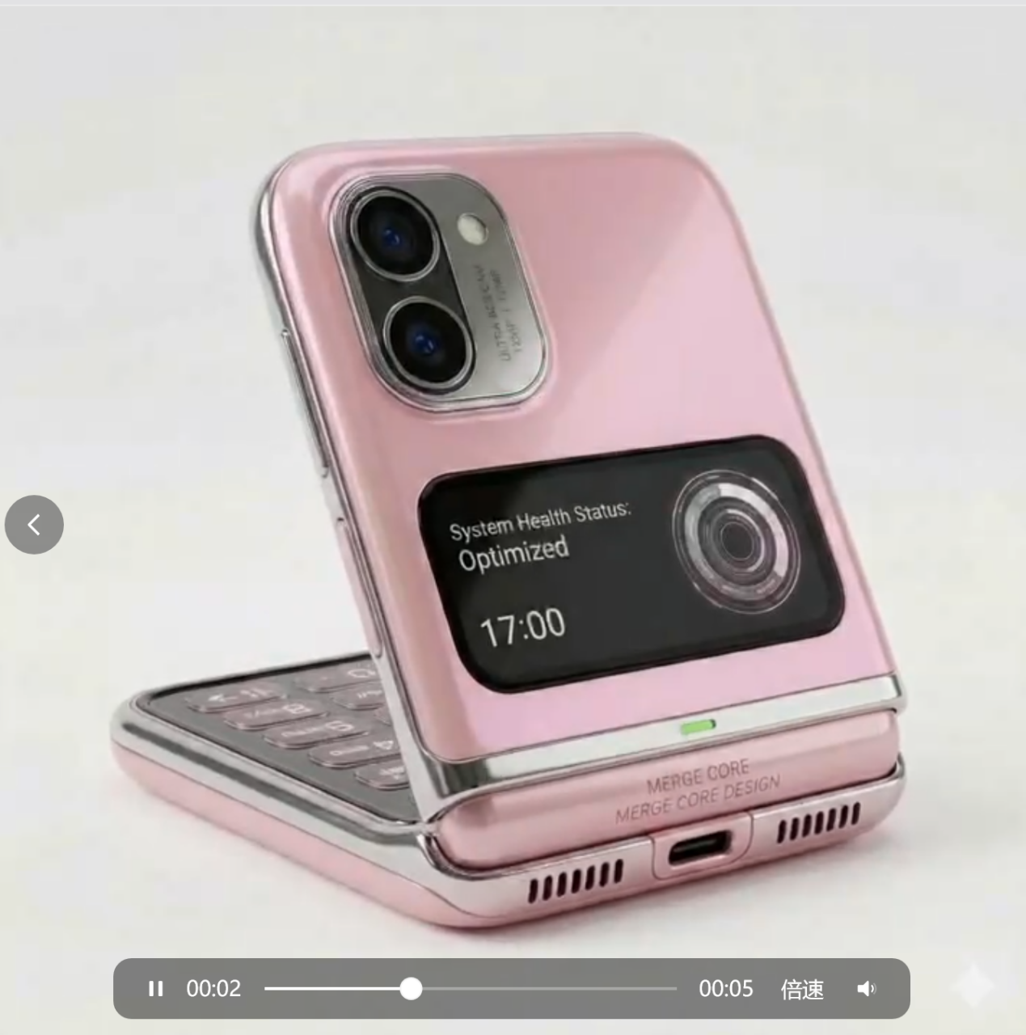
SCENE 6 — PRODUCT SHOWCASE

“high-end futuristic flip smartphone rotating slowly in cinematic lighting, softly rounded edges, elegant premium materials, subtle holographic glow, minimal luxury aesthetic, realistic futuristic product advertisement, dark clean background, ultra detailed”
场景 6 — 产品展示
“高端未来感翻盖智能手机在电影感灯光下缓慢旋转，边缘圆润柔和，材质优雅且高级，带有细微的全息光晕，极简奢华美学风格，真实的未来产品广告感，深色干净的背景，超高细节。”
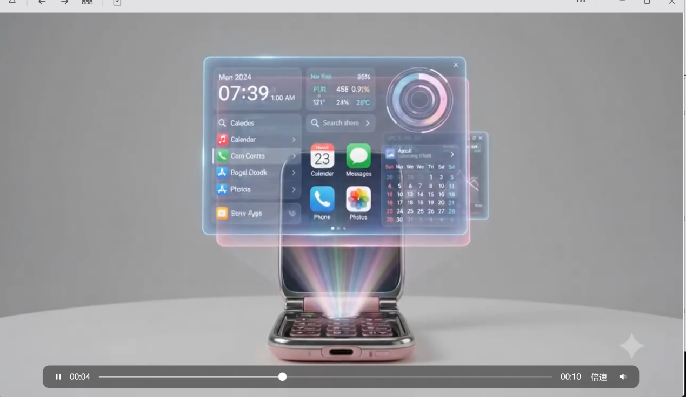
SCENE 7 — HOLOGRAM ACTIVATION

“futuristic smartphone emitting a soft beam of light that projects a floating holographic interface into the air, translucent layered UI panels, elegant holographic glow, cinematic lighting, realistic future technology, immersive atmosphere, ultra realistic”
场景 7 — 全息投影启动
“未来感智能手机发出一道柔和光束，在空中投射出悬浮的全息界面，半透明的分层 UI 面板，优雅的全息光效，电影感灯光，写实的未来科技，沉浸式氛围，超写实。”
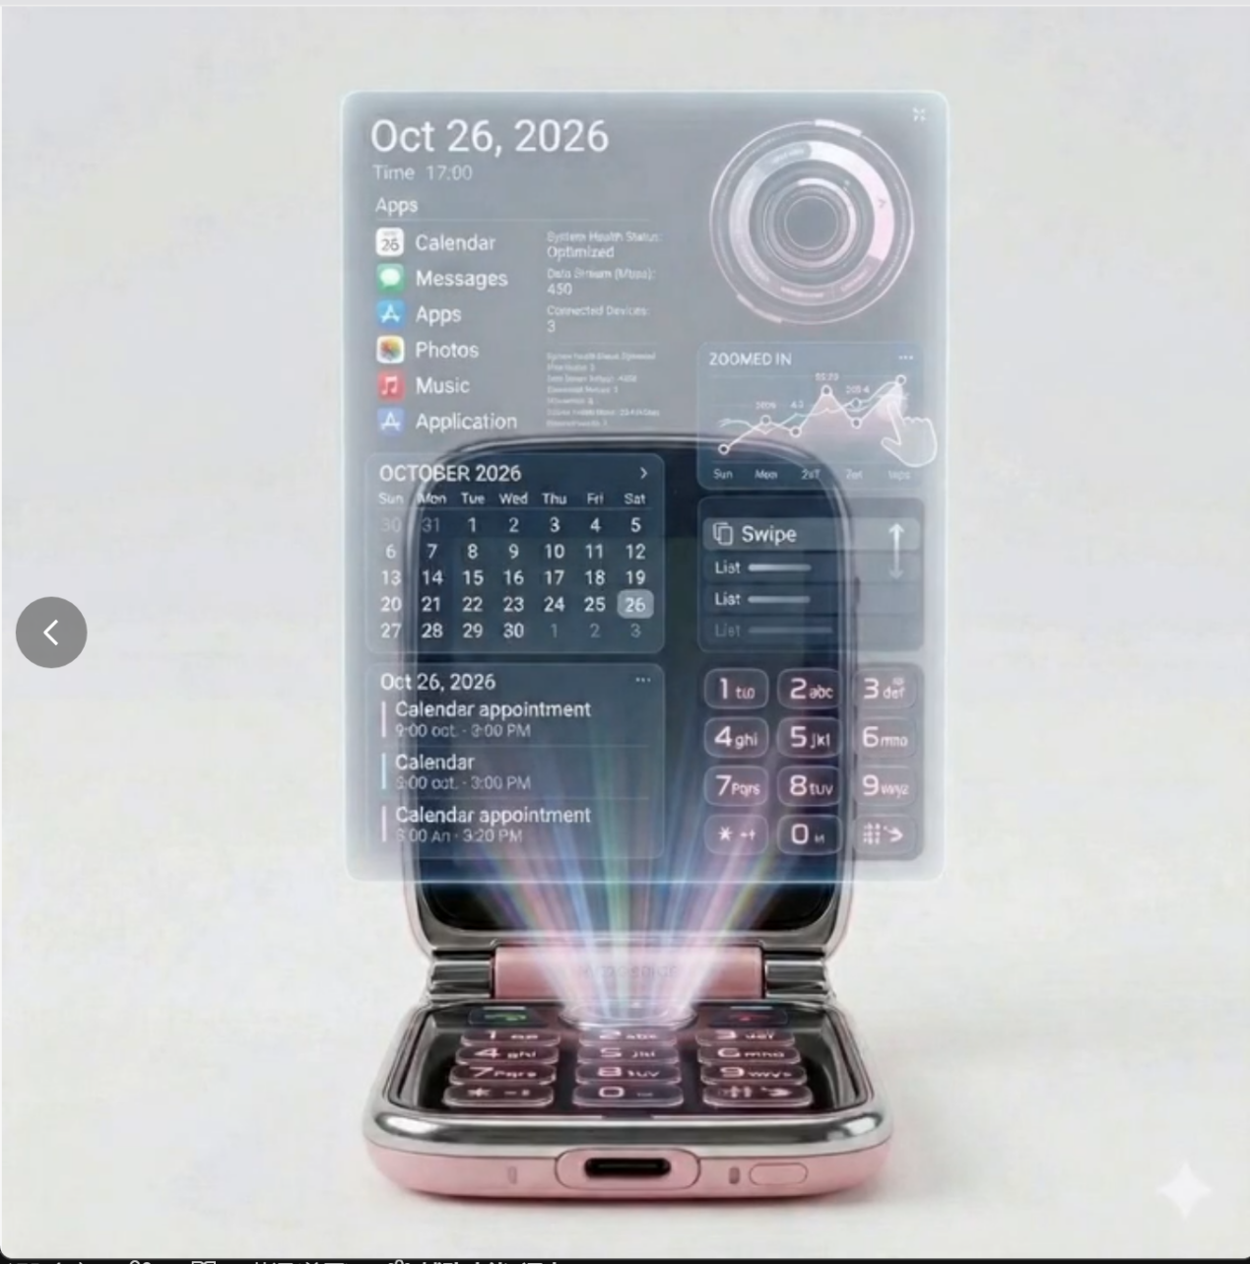
SCENE 8 — MID-AIR INTERACTION

“close-up of hands interacting with holographic interface in mid-air, swiping, pinching and scrolling gestures, glowing translucent interface reacting naturally, futuristic but believable interaction design, cinematic lighting, ultra realistic”
场景 8 — 空中交互
“手部特写，在空中与全息界面互动，进行滑动、捏合和滚动手势，发光的半透明界面自然地做出反应，未来感但可信的交互设计，电影感灯光，超写实。”
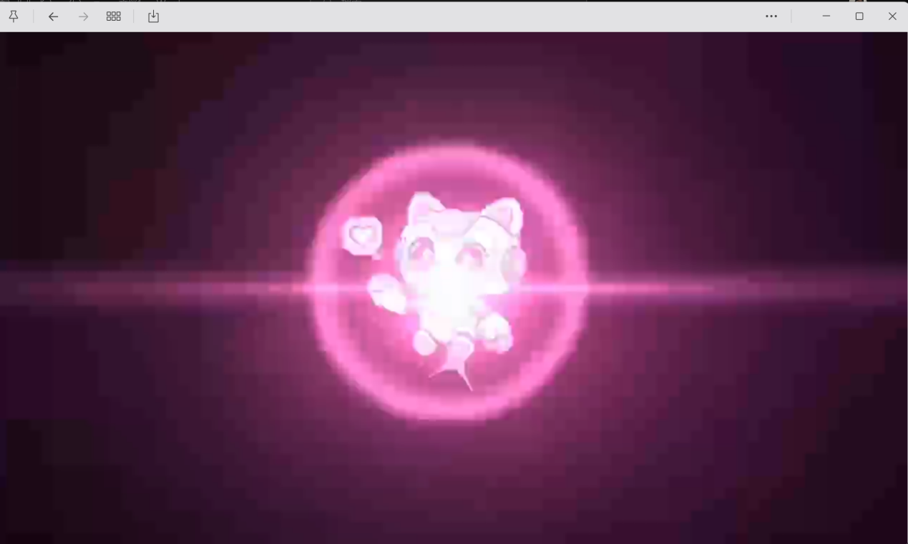
“cute futuristic holographic logo animation, soft glowing pastel pink and blue lights, floating particles assembling into a sleek logo, dreamy futuristic atmosphere, smooth elegant motion, minimal dark background, premium and emotional tech aesthetic, ultra smooth cinematic animation”
“可爱的未来感全息 Logo 动画，柔和发光的粉色与蓝色粉彩灯光，漂浮粒子逐渐汇聚成一个流畅简洁的 Logo，梦幻般的未来氛围，平滑而优雅的动态效果，极简深色背景，高端且富有情感的科技美学，超顺滑的电影感动画。”

